Optimizer | Characteristics | Suitable For
SGD | Simple, basic, updates with fixed learning rate | Good for small/simple models
Adam | Adaptive learning rate, faster convergence | Complex problems, deep networks
RMSprop | Good for non-stationary objectives (like RNNs) | Time-series or noisy gradients
Adagrad | Adjusts learning rate per parameter | Sparse data

Lesson 1: Introduction to Neural Networks
Concept:
Neural networks are computational models inspired by the structure and function of the human brain. They consist of layers of interconnected neurons:
- Input Layer: Receives input features
- Hidden Layers: Perform transformations
- Output Layer: Generates predictions
Intuition:
Neurons learn patterns through weighted connections. Adjusting these weights allows the model to learn from data—like recognizing digits, understanding language, or driving cars.

🔹 Lesson 2: Amount of Data and Deep Learning
Concept:
Deep learning models perform best with large, diverse datasets.
Intuition:
More data helps:
- Reduce overfitting
- Generalize better to unseen data
- Capture subtle, complex patterns
Example:
Image classifiers like ResNet or GPT-like models are trained on millions or billions of examples.

🔹 Lesson 3: Binary Classification
Concept:
Classify inputs into one of two categories (label = 0 or 1).
Intuition:
It’s like drawing a decision boundary between two groups—e.g., "spam" vs. "not spam", or "tumor" vs. "no tumor".
Output:
Predicted probability (0–1), then thresholded to 0 or 1.

🔹 Lesson 4: Logistic Regression
Concept:
Logistic regression predicts the probability of a binary outcome using a linear function passed through a sigmoid activation:
y^​=σ(wtx+b)=1/(1+e^−z))
Intuition:
Transforms any real number into a probability using the sigmoid function, perfect for binary classification.

🔹 Lesson 5: Logistic Regression Cost Function
Concept:
Uses cross-entropy loss to quantify how well predictions match labels:
J(w,b)=−[y∗log(y^)+(1−y)∗log(1−y^)]

Intuition:
This function penalizes incorrect confident predictions heavily, making it suitable for probabilistic classifiers.

🔹 Lesson 6: Gradient Descent
Concept:
An optimization technique to minimize the cost function by updating weights in the direction of the negative gradient.
Intuition:
Like rolling a ball downhill to reach the lowest point (minimum error).

🔹 Lesson 7: Computation Graph
Concept:
A directed acyclic graph representing a series of computations, where nodes are operations or variables.
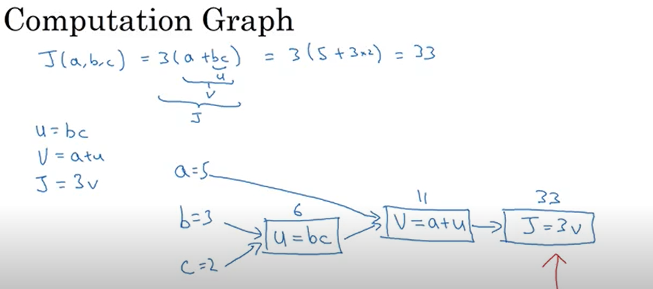
Intuition:
Helps track dependencies during forward pass and enables efficient gradient computation in backpropagation.

🔹 Lesson 8: Derivative with Computation Graph
Concept:
Use the chain rule through a computation graph to compute derivatives of the loss with respect to inputs.
Intuition:
Backpropagation flows backward through the graph, calculating gradients for each parameter.

🔹 Lesson 9: Logistic Regression Gradient Descent on Single Example
Concept:
Stochastic Gradient Descent (SGD) updates weights using one training example at a time.
Intuition:
Faster but introduces noise—sometimes helps escape local minima.

🔹 Lesson 10: Logistic Regression Gradient Descent on m Examples
Concept:
Mini-batch Gradient Descent processes batches of training examples to compute average gradients.
Intuition:
- Batch Size = 1 → SGD
- Batch Size = m → Full Gradient Descent
- In between → Mini-batch (most used)

🔹 Lesson 11: Vectorization
Concept:
Use matrix and vector operations instead of loops to perform calculations.
Intuition:
Takes advantage of optimized libraries (NumPy, PyTorch, etc.) and hardware acceleration (GPUs).

🔹 Lesson 12: Neural Networks
Concept:
Multi-layer models that transform inputs through weighted layers and activations.
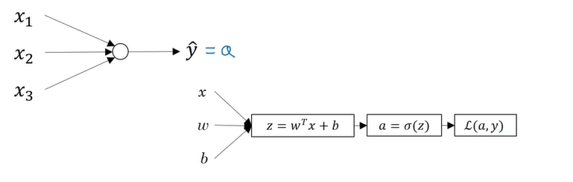
Intuition:
Each layer extracts features from previous layers—e.g., edges → shapes → faces in image recognition.

🔹 Lesson 13: Neural Network Representation
Concept:
Graphical structure:
- Circles = neurons
- Arrows = weights
- Layers = sequential computations
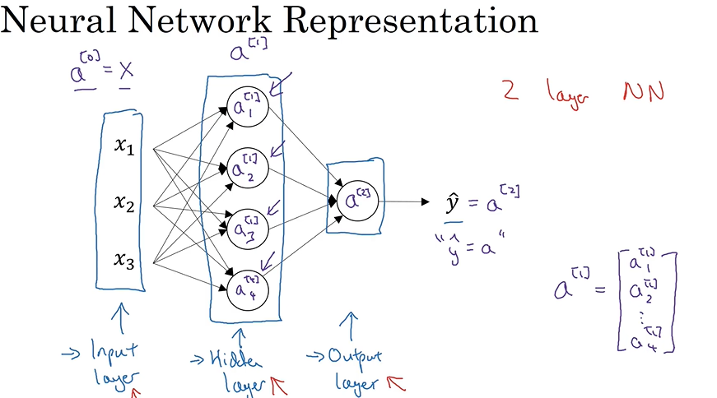
Intuition:
Helps visualize architecture: number of layers, neurons per layer, input/output flow.

🔹 Lesson 14: Neural Network Forward Pass
Concept:
Computes predictions step-by-step from input to output:
Z=W⋅X+b A=activation(Z)
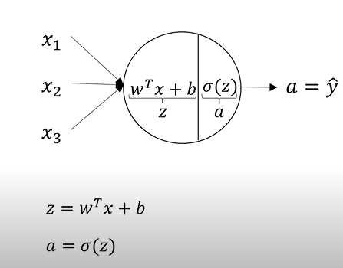
Intuition:
Applies transformations at each layer, building on the features learned so far.

🔹 Lesson 15: Vectorizing Forward Pass
Concept:
Use matrix operations to compute all activations at once for efficiency:
Z[l]=W[l]⋅A[l−1]+b[l] , A[l]=activation(Z[l])
Intuition:
Drastically speeds up training on large datasets.

🔹 Lesson 16: Activation Functions
Concept:
Introduce non-linearity to allow networks to model complex functions.
Common Types:
- Sigmoid - used for binary classification
- Tanh - used for Rnn .
- ReLU - used in hidden layer
Intuition:
Without non-linearity, neural networks behave like linear models.

🔹 Lesson 17: Non-linear Activation Functions
Concept:
Each has strengths:
- ReLU: Fast and sparse, avoids vanishing gradient
- Tanh: Zero-centered
- Sigmoid: Probabilistic outputs, but prone to saturation
Intuition:
Choosing the right one affects convergence and performance.

🔹 Lesson 18: Derivative of Activation Functions
Concept:
Required for backpropagation. Examples:
- Sigmoid derivative: σ(z)(1 - σ(z))
- ReLU derivative: 1 if z > 0, else 0
Intuition:
Efficient training relies on fast and stable gradient computation.

🔹 Lesson 19: Neural Network Backpropagation with Gradient Descent
Concept:
Computes gradients of the loss w.r.t weights using chain rule.
Steps:
- Forward pass
- Compute loss
- Backward pass (gradients)
- Update weights
Intuition:
Backprop is the engine behind training deep networks.

🔹 Lesson 20: Random Initialization
Concept:
Initial weights must be randomized (not all zero), or neurons learn the same things.
Intuition:
Breaks symmetry—ensures diverse learning paths from the start.

🔹 Lesson 21: Deep L-layer Neural Network
Concept:
Extending to multiple hidden layers (L layers) allows modeling complex tasks like translation or object detection.
Intuition:
More layers → deeper features → higher accuracy (but harder to train).

🔹 Lesson 22: Parameters & Hyperparameters
Concept:
- Parameters: Learned from data (weights, biases)
- Hyperparameters: Set manually (learning rate, layers, batch size, etc.)
Intuition:
Hyperparameter tuning is crucial to achieving optimal performance.

Lesson 23: Train/Dev/Test Sets
Concept:
Data is split into three distinct sets:
- Training Set: Used to train the model.
- Development/Validation Set: Used to fine-tune hyperparameters (like learning rate, architecture, regularization strength).
- Test Set: Used only at the end to assess final model performance and generalization.
Intuition:
Without a separate validation and test set, you risk overfitting to your training or validation data. This causes poor performance on truly unseen data.
Typical Split:
- Training: 60–80%
- Dev: 10–20%
- Test: 10–20%
Best Practices:
- Always keep the test set completely untouched until final evaluation.
- If data is small, consider cross-validation or k-fold validation.

🔹 Lesson 24: Bias and Variance
Concepts:
- High Bias → Underfitting: The model is too simple to capture patterns.
- High Variance → Overfitting: The model is too sensitive to training data noise.
Intuition:
Bias and variance are two sides of the generalization tradeoff.
- Goal: Find the sweet spot in complexity.
Diagnosing with Dev/Test Errors:
- High training error = high bias
- Large gap between training and dev/test error = high variance
How to Fix:
- High Bias: Add layers, features, or reduce regularization.
- High Variance: More training data, add regularization (L2/Dropout), or simplify the model.

🔹 Lesson 25: Regularization
Concept:
Adds a penalty term to the loss function to discourage overly complex models.
- L2 Regularization (Ridge): Adds λ * Σw²
- Helps to keep weights small → simpler model
Intuition:
Constraining weights reduces the model's ability to memorize training data, improving generalization.
Tips:
- Choose λ via validation set.
- Common in almost every deep learning model.

🔹 Lesson 26: Dropout Regularization
Concept:
Randomly "drops out" (sets to zero) a proportion of neurons during each training iteration.
Intuition:
Prevents neurons from becoming overly reliant on each other → improves robustness.
Mechanism:
- During training: Randomly deactivate neurons (e.g., keep_prob = 0.8)
- During testing: Use full network, scale outputs accordingly
Benefits:
- Reduces overfitting
- Acts like an ensemble of smaller networks

🔹 Lesson 27: Other Regularization Techniques
Key Methods:
- L1 Regularization (Lasso): Encourages sparsity by adding λ * Σ|w|
  - Useful for feature selection
- Early Stopping: Stop training when validation loss stops improving.
- Data Augmentation: Expand dataset with rotated, scaled, or modified inputs.
- Simpler Models: Reduce model size or number of parameters.
Intuition:
Different methods suit different problems. Data augmentation works great for image data; L1 helps with high-dimensional data.

🔹 Lesson 28: Normalizing Inputs
Concept:
Input features are normalized to zero mean and unit variance:
xn​orm=(x−μ)/σ
Intuition:
Prevents features with large scales from dominating the learning process.
Benefits:
- Faster convergence
- Stable gradient descent
- Avoids issues where one input scale overpowers others
Example:
In image datasets, pixel values are often scaled to [0, 1] or standardized using dataset-specific mean/std.

🔹 Lesson 29: Vanishing and Exploding Gradients
Concept:
In deep networks, gradients can:
- Vanish: Become too small to update weights (early layers stop learning).
- Explode: Grow too large, causing unstable updates.
Intuition:
Happens due to repeated multiplication of weights during backpropagation.
Especially bad with sigmoid/tanh activations or poor weight initialization.
Solutions:
- Use ReLU instead of Sigmoid/Tanh
- He or Xavier initialization
- Batch Normalization
- Residual connections (ResNets)

Lesson 30: Weight Initialization
- Concept: Weight initialization significantly impacts the convergence and stability of deep neural networks. Proper schemes like He Initialization ensure that gradients do not vanish or explode as they propagate.
- He Initialization (for ReLU):
W∼N(0,2/nin​)
- Xavier/Glorot Initialization (for tanh/sigmoid):
W∼N(0,1/nin​)
- Intuition:
  - Prevents neurons from starting with identical weights (breaking symmetry).
  - Maintains the variance of activations through layers, aiding stable learning.
  - Helps avoid vanishing/exploding gradients during forward and backward passes.

Lesson 31: Mini-batch Gradient Descent
- Concept: A compromise between full batch and stochastic gradient descent. Updates model weights using small batches (subsets) of the training data.
- Intuition:
  - Small batches introduce noise, which can help escape local minima.
  - Offers a balance between speed (like SGD) and accuracy (like batch GD).
- Trade-offs:
  - Small batch (1–32):
    - High variance in updates → more noise, faster updates.
    - May lead to unstable convergence.
  - Large batch (256–512):
    - Low variance → smoother and more accurate updates.
    - Requires more memory, may converge slower.
- Common mini-batch sizes: 32, 64, 128.

Lesson 32: Batch vs Mini-batch vs Stochastic Gradient Descent
Method | Data Used | Pros | Cons
Stochastic (SGD) | 1 sample | Very fast updates | Very noisy, unstable
Batch GD | Full dataset | Accurate gradient | Memory-heavy, slower updates
Mini-batch GD | Subset (e.g., 64 samples) | Balanced efficiency and stability | Requires tuning batch size
- Best Practice: Use mini-batches (typically powers of 2 like 32, 64, 128) for practical and scalable training.

Lesson 33: Batch Normalization
- Concept: Normalizes activations across a mini-batch to improve training speed and stability.
- Steps:
  - Compute mini-batch mean μ\muμ and variance σ2\sigma^2σ2
  - Normalize:
x^(i)=σ2+ϵ​x(i)−μ​
  - Scale and shift:
y(i)=γx^(i)+β
where γ\gammaγ, β\betaβ are learnable parameters.
- Benefits:
  - Faster convergence (can use higher learning rates)
  - Reduces dependency on weight initialization
  - Acts as a regularizer (reduces need for dropout)
  - Mitigates internal covariate shift

Lesson 34: Softmax Regression (Multinomial Logistic Regression)
- Concept: Extends logistic regression to multi-class classification tasks.
- Softmax Function:
softmax(zi​)=​e^zj​/∑ je^zi​​
where zj is the input vector of scores for each class.
- Output: A vector of probabilities that sum to 1 — each representing the confidence for a specific class.
- Loss Function: Categorical Cross-Entropy:
L=−∑​yi​log(y^​i​)
where yi​ is the true label (one-hot) and y(hat)i is the predicted probability.
- Intuition:
  - Outputs a probability distribution across multiple classes.
  - Enables training models for problems like digit recognition (0–9), sentiment classification, etc.

Lesson 35: Transfer Learning
- Concept: Leveraging a pre-trained model on a new but related task.
- Two Main Strategies:
  - Feature Extraction:
    - Freeze early layers (pre-trained on large dataset like ImageNet).
    - Only train the final classification layer on the new dataset.
  - Fine-Tuning:
    - Start with pre-trained weights.
    - Unfreeze some (or all) layers and retrain with a small learning rate.
- Intuition:
  - Early layers learn generic features (edges, textures), useful across tasks.
  - Later layers are task-specific (e.g., distinguishing between cats vs. dogs).
- Benefits:
  - Reduces data requirement.
  - Decreases training time.
  - Often improves performance on small datasets.
- Common Applications:
  - Computer Vision: Using VGG, ResNet, EfficientNet, etc.
  - Natural Language Processing: BERT, GPT, etc.
  - Speech Recognition, medical imaging, etc.

